|  |  |
| --- | --- |
|  |  |
| System Programming Practical File |  |
|  |  |
|  | Year: 3rdCourse: B. Sc. (H.) Computer Science |
|  | Abhineet Raman (2002078) |

1. Write a Lex program to count the number of lines and characters in the input file.

**Source Code: -**

%{

#include<stdio.h>

int sc=0,wc=0,lc=0,cc=0;

%}

%%

[\n] { lc++; cc+=yyleng;}

[ \t] { sc++; cc+=yyleng;}

[^\t\n ]+ { wc++; cc+=yyleng;}

%%

int main(int argc ,char* argv[ ])

{

printf("Enter the input:\n");

yylex();

printf("The number of lines=%d\n",lc);

printf("The number of spaces=%d\n",sc);

printf("The number of words=%d\n",wc);

printf("The number of characters are=%d\n",cc);

}

int yywrap( )

{

return 1;

}

**Output: -**

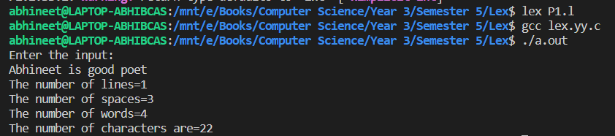

1. Write a Lex program that implements the Caesar cipher: it replaces every letter with the one three letters after in alphabetical order, wrapping around at Z. e.g. a is replaced by d, b by e, and so on z by c.

**Source Code: -**

%{

#include<stdio.h>

#include<stdlib.h>

%}

%%

[a-z] {

char ch = yytext[0];

ch += 3;

if(ch > 'z')

ch -= ('z'+1 - 'a');

printf("%c",ch);

yytext[0] = ch;

}

[A-Z] {

char ch = yytext[0];

ch += 3;

if(ch > 'Z')

ch -= ('Z'+1 - 'A');

printf("%c",ch);

yytext[0] = ch;

}

%%

int main(){

yyin = fopen("input.txt","r");

yylex();

return 0;

}

yywrap(){}

yyerror(){}

**Output: -**

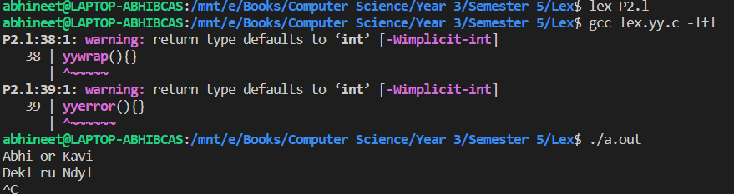

1. Write a Lex program that finds the longest word (defined as a contiguous string of upper- and lower-case letters) in the input.

**Source Code: -**

%{

//to find longest string and its length

#include<stdio.h>

#include<string.h>

int longest = 0;

char longestString[30];

%}

%%

[a-zA-Z]+ {

if(yyleng>longest){

longest = yyleng;

strcpy(longestString,yytext);

}

}

%%

int main(void){

yylex();

printf("The longest string is %s \n", longestString);

printf("Length of a longest string is %d \n",longest);

}

**Output: -**

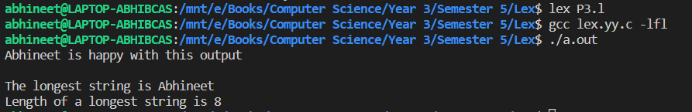

1. Write a Lex program that distinguishes keywords, integers, floats, identifiers, operators, and comments in any simple programming language.

**Source Code: -**

%{

#include<stdlib.h>

#include<stdio.h>

%}

%%

(void|int|float|double|string|return|bool|char|for|if|do|while|exit"("[0-9]+")"|case|break|continue|switch|enum|struct|"size of") { printf("\n%s -> ",yytext);

printf("%s\n","Keyword");}

[0-9]+ {printf("\n%s -> ",yytext);

printf("%s\n","Integer");}

[0-9]*(.)[0-9]+('f'|'d'){1} {printf("\n%s -> ",yytext);

printf("%s\n","Float");}

[_a-zA-Z]+[_a-zA-Z0-9]* { printf("\n%s -> ",yytext);

printf("%s\n","Identifier");}

[+*/&<>|()-=] { printf("\n%s -> ",yytext);

printf("%s\n","Operator");}

"//".* {printf("\n%s -> ",yytext);

printf("%s\n","Single Line Comment");}

"/*".*"*/" {printf("\n%s -> ",yytext);

printf("%s\n","Multi Line Comment");}

\t ;

\n ;

" ";

. { printf("\n%s -> ",yytext);

printf("%s\n","Special Character");}

%%

int main(){

yylex();

return 0;

}

yywrap(){}

yyerror(){}

**Output: -**

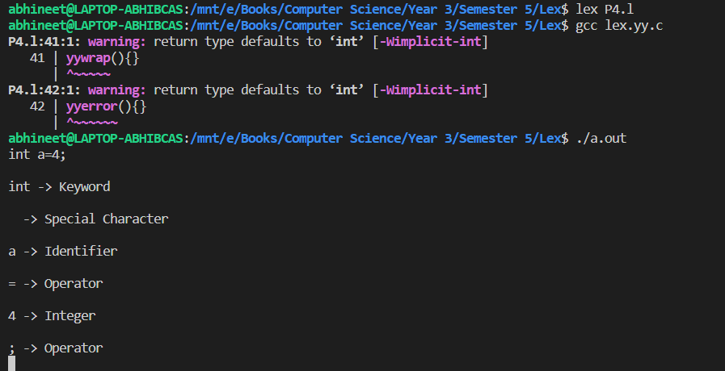

1. Write a Lex program to count the number of identifiers in a C file.

**Source Code: -**

%{

#include<stdlib.h>

#include<stdio.h>

int num=0;

%}

%%

"int" |

"float" |

"char" |

"double" |

"bool" {

char ch;

ch = input();

while(1){

if(ch == ','){

num++;

}

if(ch == ";"){

num++;

break;

}

if(ch == '\n')

break;

ch = input();

}

}

.|'\n' ;

%%

int main(int argc,char *argv[]){

if(argc!=2){

printf("\n\tYou didn't specify file in arguement\n");

exit(0);

}

else{

yyin = fopen(argv[1],"r");

if(yyin){

yylex();

printf("\nNo. of Identifiers = %d\n",num);

}

else{

printf("\n\tError while opening file\n");

}

}

return 0;

}

yywrap(){}

yyerror(){}

**Output: -**

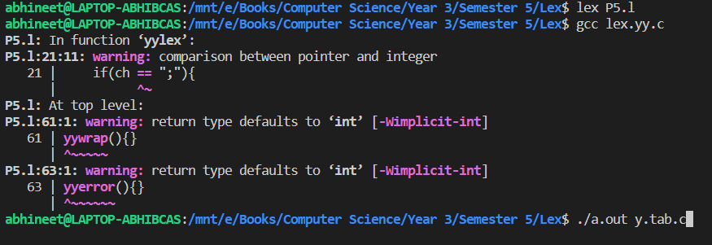

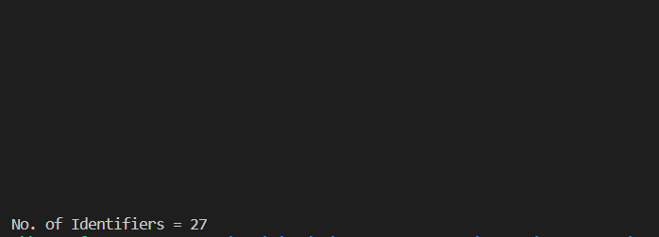

1. Write a Lex program to count the number of words, characters, blank spaces and lines in a C file.

**Source Code: -**

%{

#include<stdio.h>

#include<strings.h>

#include<stdlib.h>

int yyflex();

int lines=0,words=0,Characters=0,blank=0;

%}

%%

[^ \t\n]+ {words++;

Characters+=yyleng;}

[\n] {lines++;}

" " blank++;

\t blank+=5;

%%

int main(){

yyin = fopen("input.txt","r");

yylex();

printf("\n\t=============== This file contains ==============\n");

printf("\tTotal %d Lines\n",lines);

printf("\tTotal %d words\n",words);

printf("\tTotal %d Characters \n",Characters);

printf("\tTotal %d Blanks \n",blank);

return 0;

}

yywrap(){}

yyerror(){

printf("\nError\n");

exit(0);

}

**Output: -**

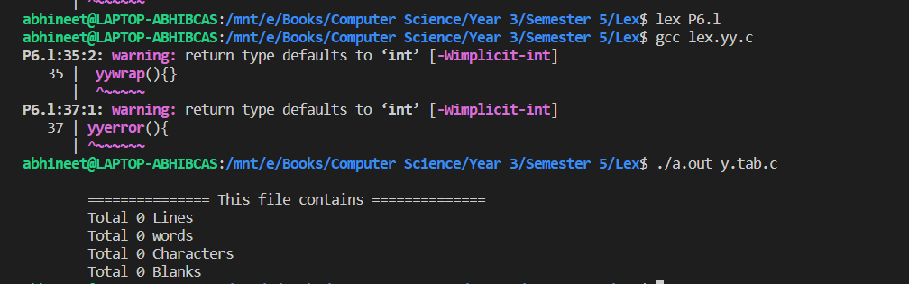

7. Write a Lex specification program that generates a C program which takes a string “abcd” and prints the following output.

abcd

abc

ab

a

**Source Code: -**

%{

#include<stdio.h>

#include<stdlib.h>

%}

%%

[a-zA-Z]* {

for(int i=yyleng-1;i>=0;i--){

printf("\t\t");

for(int j=0;j<=i;j++)

printf("%c\t",yytext[j]);

printf("\n");

}

}

%%

int main(){

yylex();

return 0;

}

int yywrap(){

return 0;

}

int yyerror(){

printf("\n******* ERROR *******\n");

exit(1);

}

**Output: -**

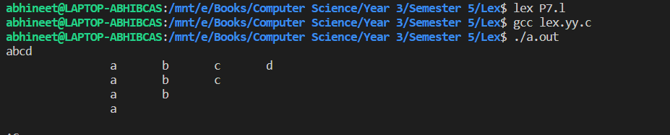

8. A program in Lex to recognize a valid arithmetic expression.

**Source Code: -**

/* Lex program to recognize valid arithmetic expression

and identify the identifiers and operators */

%{

#include <stdio.h>

#include <string.h>

int operators_count = 0, operands_count = 0, valid = 1, top = -1, l = 0, j = 0;

char operands[10][10], operators[10][10], stack[100];

%}

%%

"(" {

top++;

stack[top] = '(';

}

"{" {

top++;

stack[top] = '{';

}

"[" {

top++;

stack[top] = '[';

}

")" {

if (stack[top] != '(') {

valid = 0;

}

else if(operands_count>0 && (operands_count-operators_count)!=1){

valid=0;

}

else{

top--;

operands_count=1;

operators_count=0;

}

}

"}" {

if (stack[top] != '{') {

valid = 0;

}

else if(operands_count>0 && (operands_count-operators_count)!=1){

valid=0;

}

else{

top--;

operands_count=1;

operators_count=0;

}

}

"]" {

if (stack[top] != '[') {

valid = 0;

}

else if(operands_count>0 && (operands_count-operators_count)!=1){

valid=0;

}

else{

top--;

operands_count=1;

operators_count=0;

}

}

"+"|"-"|"*"|"/" {

operators_count++;

strcpy(operators[l], yytext);

l++;

}

[0-9]+|[a-zA-Z][a-zA-Z0-9_]* {

operands_count++;

strcpy(operands[j], yytext);

j++;

}

%%

int yywrap()

{

return 1;

}

int main()

{

int k;

printf("Enter the arithmetic expression: ");

yylex();

if (valid == 1 && top == -1) {

printf("\nValid Expression\n");

}

else

printf("\nInvalid Expression\n");

return 0;

}

**Output: -**

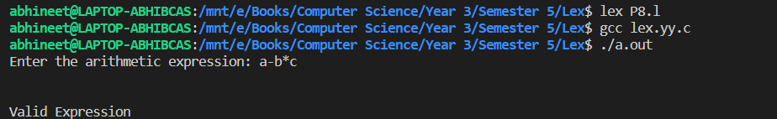

9. Write a YACC program to find the validity of a given expression (for operators + - * and /)

**Source Code (Lex): -**

%{

/* 4a.l Yacc Program to check the validity of an arithmetic Expression that uses operators +, -, *, /

*/

#include "y.tab.h"

%}

%%

[0-9]+(\.[0-9]+)? { return NUM;}

[a-zA-Z_][_a-zA-Z0-9]* { return ID; }

[\t] ;

\n return 0;

. return yytext[0];

%%

yywrap()

{}

**Source Code (Yacc): -**

%{

/* 4a.y Yacc Program to check the validity of an arithmetic Expression that uses operators +, -, *, /

*/

#include<stdio.h>

#include<stdlib.h>

%}

%token NUM ID

%left '+' '-'

%left '*' '/'

%%

e : e '+' e

| e '-' e

| e '*' e

| e '/' e

| '('e')'

| NUM

| ID ;

%%

main()

{

printf(" Type the Expression & Press Enter key\n");

yyparse();

printf(" Valid Expression \n");

}

yyerror()

{

printf(" Invalid Expresion!!!!\n"); exit(0);

}

**Output: -**

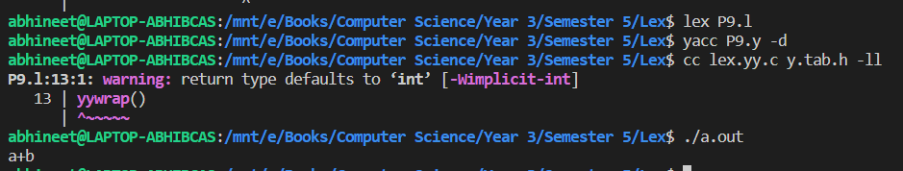

10. A Program in YACC which recognizes a valid variable which starts with letter followed by a digit. The letter should be in lowercase only.

**Source Code (Lex): -**

%{

#include"y.tab.h"

%}

%%

[a-zA-Z] {return LETTER;}

[0-9] {return DIGIT;}

[_] {return UND;}

[\n] {return NL;}

. {return yytext[0];}

%%

**Source Code (Yacc): -**

%{

#include<stdio.h>

#include<stdlib.h>

%}

%token DIGIT LETTER UND NL

%%

stmt: variable NL {printf("valid identifiers\n"); exit(0);}

;

variable: LETTER alphanumeric

;

alphanumeric: LETTER alphanumeric | DIGIT alphanumeric | UND alphanumeric | LETTER | DIGIT | UND

;

%%

int yyerror(char *msg)

{

printf("Invalid variable\n");

exit(0);

}

main()

{

printf("enter the variable: \n");

yyparse();

}

**Output: -**

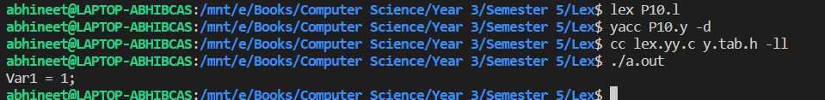

11. A Program in YACC to evaluate an expression (simple calculator program for addition and subtraction, multiplication, division).

**Source Code (Lex): -**

%{

#include<stdio.h>

#include<stdlib.h>

#include "y.tab.h"

int yylval;

%}

%%

[0-9]+ {yylval = atoi(yytext);

return NUM;}

[\t]+ ;

\n {return 0;}

. {return yytext[0];}

%%

**Source Code (Yacc): -**

%{

#include<stdio.h>

#include<stdlib.h>

#include "y.tab.h"

%}

%token NUM

%left '+' '-'

%left '/' '*'

%left '(' ')'

%%

expr:e{printf("Result is :: %d\n",$$);

return 0;}

e:e '+' e{$$ = $1+$3;}

|e '-' e{$$ = $1-$3;}

|e '*' e{$$ = $1*$3;}

|e '/' e{

if($3==0){

printf("\nDivision By Zero\n");

printf("Result is :: Undefined");

return 0;

}

else

$$ = $1/$3;}

|'(' e ')'{$$ = $2;}

|NUM {$$ = $1;}

%%

int main(){

printf("\nEnter the arithmetic expression ::");

yyparse();

printf("\nValid Expression\n");

return 0;

}

int yywrap(){

return 0;

}

int yyerror(){

printf("\nInvalid Expression\n");

exit(1);

}

**Output: -**

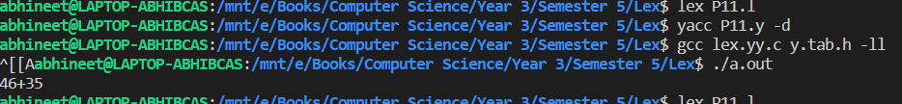

12. Program in YACC to recognize the strings “ab”, “aabb”, “aaabbb”, … of the language (anbn, n>=1).

**Source Code (Lex): -**

%{

#include<stdio.h>

#include<stdlib.h>

#include "y.tab.h"

%}

%%

[a] {return A;}

[b] {return B;}

\n {return NL;}

. {return yytext[0];}

%%

**Source Code (Yacc): -**

%{

#include<stdio.h>

#include<stdlib.h>

#include "y.tab.h"

%}

%token A B NL

%%

expr : S NL{printf("\nValid String\n");

return 0;}

S : A S B

|;

%%

int main(){

printf("\nEnter the string :: ");

yyparse();

return 0;

}

yywrap(){}

yyerror(){

printf("\nInvalid String");

}

**Output: -**

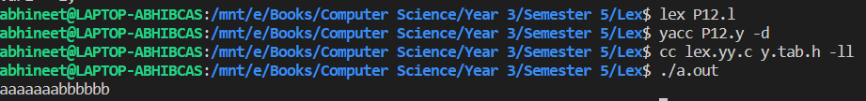

13. Program in YACC to recognize the language (anb, n>=10). (Output to say input is valid or not)

**Source Code (Lex): -**

%{

#include<stdio.h>

#include<stdlib.h>

#include "y.tab.h"

%}

%%

[a] {return A;}

[b] {return B;}

\n {return NL;}

. {return yytext[0];}

%%

**Source Code (Yacc): -**

%{

#include<stdio.h>

#include<stdlib.h>

#include "y.tab.h"

%}

%token A B NL

%%

S : A A A A A A A A A A S1 B NL

{ printf("\nValid String \n");

return 0;}

S1 : A S1

|;

%%

main(){

printf("\nEnter a String :: ");

yyparse();

}

yywrap(){}

yyerror(){

printf("\nInvalid String\n");

return 0;

}

**Output: -**

